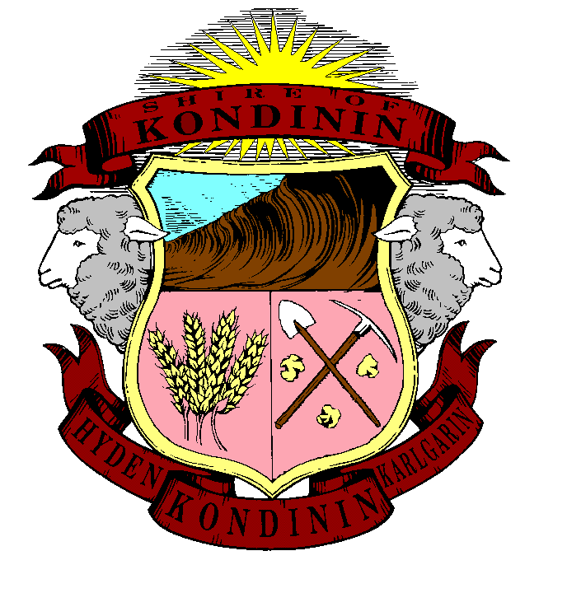
Shire of kondinin
Minutes of meeting
Kondinin Shire Council

Special Council Meeting
Held at the Microsoft Teams on 29 July 2026

This page is intentionally left blank.

Order of Business
1 Opening of Meeting 4
2 Acknowledgement of Traditional Owners and Dignitaries 4
3 Recording ofAttendance 4
3.1 Attendance 4
3.2 Attendance by Telephone or Instantaneous Communication 4
3.3 Apologies 4
3.4 Approved Leave of Absence 4
3.5 Declarations of Disclosures of Interest 5
4 Application for Leave of Absence 5
5 Public Time 5
5.1 Public Question Time 5
5.2 Public Statement Time 5
6 Questions from Members without Notice 5
7 Announcements by Presiding Members without Discussion 5
8 Declaration of Members to have Given due Consideration to all Matters Contained in the Agenda Before the Meeting 5
9 Business of an Urgent Nature 5
10 Matters for which Meeting may be Closed / Confidential Items 6
11 Decisions Made while Meeting was Closed to the Public 7
10.1 Hyden (Wave Rock-Katter Kich) Discovery Centre - Hyden Progress Association Memorandum of Understanding & Section 3.59 Compliance. 7
10.2 Appointment - Executive Manager Infrastructure 10
While the meeting was closed to the public, Council considered Item 10.1, Hyden (Wave Rock-Katter Kich) Discovery Centre - Hyden Progress Association Memorandum of Understanding and Section 3.59 Compliance. 10
Council resolved in favour of Option 2 in accordance with the Officer Recommendation. 10
Council also considered Item 10.2, Appointment – Executive Manager Infrastructure and resolved that Mr Robert Edwards is appointed as the Executive Manager Infrastructure of the Shire of Kondinin. 10
12 Close of Meeting 11
12.1 Date of Next Meeting 11
12.2 Closure 11

1 Opening of Meeting
The meeting was opened by the Shire President at 4.10pm

2 Acknowledgement of Traditional Owners and Dignitaries
The Shire of Kondinin Council pays its respects to the traditional owners of the land upon which we meet and elders past, present and emerging.

3 Recording ofAttendance

3.1 Attendance
Shire President K Mouritz (Presiding Member), Deputy Shire President B Gangell (Deputy Presiding Member), Cr B Browning, Cr M James, Cr D Pool, Chief Executive Officer B Wright, Manager Planning & Assets Mrs T Young, Manager Corporate Services Mr V Bugna, Cr T Smeed, Mrs A Kemp

3.2 Attendance by Telephone or Instantaneous Communication
This meeting is being convened by instantaneous community – Microsoft Teams due to the unavoidable short notice and priority of the matters before Council.
Motion
Resolution OCM/26/099
Moved: Cr Kent Mouritz
Seconded: Cr Beverley Gangell
That Council approves for this meeting to proceed by instantaneous communication.
carried 7/0
For: Crs Kent Mouritz, Beverley Gangell, Bruce Browning, Murray James, Darren Pool, Toni Smeed and Paul Green
Against: Nil

3.3 Apologies
Nil

3.4 Approved Leave of Absence
Cr Paul Green – in attendance on leave.

3.5 Declarations of Disclosures of Interest
Crs Mouritz & Green declared impartiality interests by virtue of membership of the Hyden Progress Association. The interests are not financial or proximity.

4 Application for Leave of Absence
Nil

5 Public Time

5.1 Public Question Time
Nil

5.2 Public Statement Time
Nil

6 Questions from Members without Notice
Nil

7 Announcements by Presiding Members without Discussion
Nil

8 Declaration of Members to have Given due Consideration to all Matters Contained in the Agenda Before the Meeting
All Councillors declared by way of a show of hands that they have given due consideration to all matters contained within the agenda before the meeting.

9 Business of an Urgent Nature
Nil

10 Matters for which Meeting may be Closed / Confidential Items
Resolution OCM/26/100
Moved: Cr Kent Mouritz
Seconded: Cr Murray James
That Council considers the confidential report(s) listed below in a meeting closed to the public in accordance with Section 275 of the Local Government Act 2012:
10.1 Hyden (Wave Rock-Katter Kich) Discovery Centre - Hyden Progress Association Memorandum of Understanding & Section 3.59 Compliance.
This matter is considered to be confidential under Section 5.23 - (4)(a) of the Local Government Act, and the Council is satisfied that discussion of this matter in an open meeting would, on balance, be contrary to the public interest as it deals with legal advice, or other information, over which the local government holds legal professional privilege.
10.2 Appointment - Executive Manager Infrastructure
This matter is considered to be confidential under Section 5.23 - (2)(b) of the Local Government Act, and the Council is satisfied that discussion of this matter in an open meeting would, on balance, be contrary to the public interest as it deals with a matter relating to the recruitment or employment of the CEO or a senior employee, including the following:
(i) the termination of employment;
(ii) a review of performance under section 5.38..

carried 7/0
For: Crs Kent Mouritz, Beverley Gangell, Bruce Browning, Murray James, Darren Pool, Toni Smeed and Paul Green
Against: Nil

Resolution OCM/26/105
Moved: Cr Toni Smeed
Seconded: Cr Bruce Browning
Resume in Open Session and note the President's report on Confidential Resolutions.

carried 7/0
For: Crs Kent Mouritz, Beverley Gangell, Bruce Browning, Murray James, Darren Pool, Toni Smeed and Paul Green
Against: Nil

11 Decisions Made while Meeting was Closed to the Public

10.1 Hyden (Wave Rock-Katter Kich) Discovery Centre - Hyden Progress Association Memorandum of Understanding & Section 3.59 Compliance.
File Number:
Date:
Author: Bruce Wright, Chief Executive Officer
AUTHORISED OFFICER: Bruce Wright, Chief Executive Officer
DISCLOSURE OF INTEREST: Author - Nil
Authoriser - Nil

The Council is satisfied that, pursuant to Section 5.23 of the Local Government Act 1995, the information to be received, discussed or considered in relation to this agenda item is:
(4)(a) legal advice, or other information, over which the local government holds legal professional privilege.
The Council is satisfied that, pursuant to Section 5.23 of the Local Government Act 1995, the information to be received, discussed or considered in relation to this agenda item is:
(4)(a) legal advice, or other information, over which the local government holds legal professional privilege.
esolution OCM/26/001
Moved: Cr Paul Green
Seconded: Cr Beverley Gangell
That Council, by absolute majority:
1. Notes the legal advice received from McLeods Barristers and Solicitors dated 7 July 2026 and the supplementary legal advice received on 14 July 2026 regarding the Hyden (Wave Rock – Katter Kich) Discovery Centre project;
2. Notes that material doubt exists as to whether the Shire's previous section 3.59 process was validly completed and whether the current project model is significantly different from the proposal previously advertised.
3. Determines that the Shire's preferred course of action is Option 2 as set out in the Options Analysis section of this report:
Option 2 - Conditional Continuation: Proceed with the replacement Option A Memorandum of Understanding and current Lottery west grant application work on a conditional basis, provided that the Memorandum of Understanding is amended to be expressly conditional upon section 3.59 compliance and to ensure that it does not fetter Council’s statutory discretion.
4. Notes the supplementary advice that it is open to the Shire to proceed with and execute the Option A Memorandum of Understanding before completion of a fresh section 3.59 process, provided that the Memorandum of Understanding is amended to make clear that:
a) the Memorandum of Understanding is conditional upon the Shire’s compliance with section 3.59 of the Local Government Act 1995; and
b) the Memorandum of Understanding does not fetter Council’s statutory discretion, including Council’s discretion whether to proceed with the project following consideration of submissions under section 3.59(5).
5. Authorises the Chief Executive Officer to negotiate and execute a replacement Option A Memorandum of Understanding with the Hyden Progress Association, provided that the Memorandum of Understanding is first amended, to the satisfaction of the Chief Executive Officer, to include provisions giving effect to item 8 below and, to the extent relevant, the restrictions in item 9 below.
6. Resolves that the replacement Option A Memorandum of Understanding must expressly provide that it is conditional upon the Shire’s compliance with section 3.59 of the Local Government Act 1995 and must not bind, commit, fetter or otherwise constrain Council in the exercise of its statutory discretion, including Council’s discretion under section 3.59(5) whether to proceed with the project after considering any submissions received.
7. Resolves that the Shire may continue work on the current Lottery west grant funding application, provided that the Shire does not enter into a binding funding agreement, construction contract, land transaction or other binding implementation agreement until section 3.59 compliance has been achieved, or further legal advice confirms that the proposed step is permissible.
8. Confirms that Council’s endorsement, made under clause 8 of Resolution 4645, that in the event the Shire’s current application for Lottery west grant funding is unsuccessful, the Shire will cease all further activity on the Discovery Centre project and no further Shire resources, funding or staff time will be committed to it, remains in effect unless and until Council resolves otherwise, and that nothing in this resolution alters, supersedes or diminishes that endorsement.
9. Notes that Resolution 4645 cannot be treated as having no historical effect because actions have already been taken under it, including execution of the Option B Memorandum of Understanding; however, Council may revoke or change its operative effect prospectively in accordance with regulation 10 of the Local Government (Administration) Regulations 1996.
10. Notes that formal repeal or variation of the specific items of Resolution 4645 is not sought at this meeting and will instead be brought back to Council once the option determined under item 3 has produced a settled replacement instrument or process, to avoid prematurely removing provisions that may still have operative effect depending on the pathway adopted.
11. Authorises the Chief Executive Officer to negotiate termination by agreement of the executed Option B Memorandum of Understanding with the Hyden Progress Association.
12. Endorses and approves the application of regulation 11(2)(f) of the Local Government (Functions and General) Regulations 1996 to retain Ms Juliet Grist as Principal Project Consultant, Site Architecture Studio as project architect, and Creative Spaces as specialist interpretive/design consultant for the Hyden Discovery Centre project, on the basis that the Shire has good reason to believe that, because of the unique nature of the services required, prior project involvement, project-specific knowledge and continuity requirements, it is unlikely that there is more than one potential supplier for the required services.
13. Requests the Chief Executive Officer to report back to Council before the Shire enters into any contract, agreement or arrangement, other than the conditional and non-binding Option A Memorandum of Understanding authorised by this resolution, that would constitute a major land transaction, or a binding land transaction preparatory to a major land transaction, for the purposes of section 3.59 of the Local Government Act 1995.
14. Notes that the matter previously listed as Item 12.4.6, Hyden Discovery Centre - Hyden Progress Association Memorandum of Understanding, laid on the table at the Ordinary Meeting of Council held on 17 June 2026, has been taken from the table and is now dealt with through Item 10.1, Hyden (Wave Rock-Katter Kich) Discovery Centre - Hyden Progress Association Memorandum of Understanding and Section 3.59 Compliance.

carried 4/3 by Absolute Majority
For: Crs Kent Mouritz, Beverley Gangell, Murray James and Paul Green
Against: Crs Bruce Browning, Darren Pool and Toni Smeed

10.2 Appointment - Executive Manager Infrastructure
File Number:
Date:
Author: Bruce Wright, Chief Executive Officer
AUTHORISED OFFICER: Bruce Wright, Chief Executive Officer
DISCLOSURE OF INTEREST: Author - Bruce Wright
Authoriser - Bruce Wright

The Council is satisfied that, pursuant to Section 5.23 of the Local Government Act 1995, the information to be received, discussed or considered in relation to this agenda item is:
(2)(b) a matter relating to the recruitment or employment of the CEO or a senior employee, including the following:
(i) the termination of employment;
(ii) a review of performance under section 5.38.
Resolution OCM/26/002
Moved: Cr Murray James
Seconded: Cr Beverley Gangell
That Council:
1. Accepts the recommendation of the Chief Executive Officer to employ Mr Robert Lennon Edwards in the designated senior employee position of Executive Manager Infrastructure; and
2. Notes that the appointment is to be governed by a written contract in accordance with section 5.39 of the Act, for a maximum term of three (3) years commencing on 1 August 2026, on the remuneration and terms set out in this report.

carried 7/0
For: Crs Kent Mouritz, Beverley Gangell, Bruce Browning, Murray James, Darren Pool, Toni Smeed and Paul Green
Against: Nil

While the meeting was closed to the public, Council considered Item 10.1, Hyden (Wave Rock-Katter Kich) Discovery Centre - Hyden Progress Association Memorandum of Understanding and Section 3.59 Compliance.

Council resolved in favour of Option 2 in accordance with the Officer Recommendation.

Council also considered Item 10.2, Appointment – Executive Manager Infrastructure and resolved that Mr Robert Edwards is appointed as the Executive Manager Infrastructure of the Shire of Kondinin.

12 Close of Meeting

12.1 Date of Next Meeting
To be held at 4pm at Karlgarin Country Club on Wednesday 19 August 2026.

12.2 Closure
The Meeting closed at 4.31pm.

